April Newsletter in Isolation

Chairman’s Message
This week in Bendigo there were to be many State Bowling events which had been planned for twelve months or more. Sadly the State Disabilities Championships at Golden Square, the 60 and Over Championships at Bendigo and the State Championships at Bendigo East had to be cancelled or postponed. On Friday 17th April, the Inaugural Hall of Fame was to be held at the All Seasons Venue but was cancelled!
Clubs are unable to open for normal business and all Bowlers are feeling the effects of being in lockdown. We are missing the companionship of friends as well as the physical aspects of putting down a bowl.
On Wednesday 22nd April we would normally be able to celebrate our successes at our Annual Presentation Night. Each year this is a very special occasion and awards all those who won Pennants, and Division and Region Championships.
The Division Board wishes to present these awards at some future time. As these awards are very special, we are mindful that some sort of public acknowledgement should be made. When this will occur is of course unable to be planned for at present.
Clubs and The BBD are reaching their AGM times. There are notices being put out by Secretary Geoff and John Emerson from BA regarding information on this matter.
This Division has recently strongly spoken out to BV that we cannot make any decisions regarding their issue of removing Divisions and only having Regions. We are not alone. We need time to absorb the implications and as we cannot meet, a moratorium on this issue is necessary. All Clubs will be kept informed on anything relating to this matter.
Good wishes to all our members. Keep safe and hopefully one day, very soon we can meet on the green!
Marian Craze
Chair

-------------------------------------------------------------------------------------------------------------------------------
State Events Winners
Champion of Champions-Men- Winner Lawrence Brooks (Bendigo) Runner-up Greg Brain (Castlemaine) Women- Taylah Marron (Bendigo East) Runner-up Stephanie Priest (Bendigo)
State Singles
Men- Winner Lee Schraner (Bendigo East) Runner-up Ken Rusbridge (Eaglehawk)
Women- Winner Helen Clough (Bendigo East) Runner-up Kaye Rowe (Eaglehawk)
State Pairs
Men- Winner Brad Marron/ Lee Schraner (s) Bendigo East Runner Up- Cohen Balnaves/ James Oliver (s) Bendigo
Women- Jean Belt/ Val White (s) Bendigo Runner-up Nancy Tate/ Sylvia Lord (s) Bendigo

State Triples
Men- Winner Liam Crapper, Greg Page, Brad Holland (s) South Bendigo Runner-up Luke Hoskin, Frank Byrne, Ian Ross (s) Composite
Women- Ruth Pearce, Julie Robins, Veronika Groves (s) Golden Square Runner-up
Jan Ovenden, Marg Bennet, Val White (s) Bendigo
State Fours
Men- Winner- Bruce Morley, Mick Manning, Tori Babitsch, Ian Ross (s) Composite
Runner-up- Graeme Edwards, Marc Smith, Brad Marron, Lee Schraner (s) Bendigo East.
Women- Winner Brooke Davies, Jan Palmer, Gwen Waegeli, Susan Howes (s) Kangaroo Flat
Runner-up- Pat Devereaux, Carrol Frost, Pam Hunter, Tricia O’Shea (s) Castlemaine
60 & Over Singles
Men- Winner-Phil Godkin (Eaglehawk) Runner-up Geoff Boyd (Kangaroo Flat)
Women- Winner- Susan Howes (Kangaroo Flat) Runner-up- Julie Ross (Golden Square)
60 & Over Pairs
Men- Winner Geoff Wilson/ Lindsay Kelly (s) Inglewood Runner-up Alan Eddy/ Wayne Robins (s) Golden Square
Winner- Judy Davey/ Helen Clough (s) Bendigo East Runner-up Pam Hunter/ Tricia O’Shea (s) Castlemaine
Novice Singles
Men- Josh Wiffen (South Bendigo) Runner-up Steve Driessen (South Bendigo)
Women- Dawn Gibbs (Eaglehawk) Runner-up- Jeni Eddy (Golden Square)
State Mixed Pairs
Winner- Taylah Marron/Lee Schraner (s) Bendigo East Runner-up Vicky Tierney/ Lindsay Kelly (s) Inglewood
Midweek Pennant (Anniversary) Fours
Winner- Lindsay Troy, Eric White, Brooke Davies, Gwen Waegeli (s) Kangaroo Flat
Runner-up- Robert Clough, Jenny Clough, Carol Gallop, Ann Borham (s) Bendigo East.
Region Finals
Novice Singles–
Men- Josh Wiffen (South Bendigo) def Adam Cowley (Mathoura) 21/4
Women’s’- Dawn Gibbs (Eaglehawk) lt Robyn Tooley (Echuca)18/21 (Josh Wiffen was defeated in the last 16 playoffs at Mulgrave Country Club, Robyn Tooley has won her way to the State Final)
Men’s Fours- Allen Buzzer, Richard Blain, Alan Jones, Merv Harvey (Moama) def Bruce Morley, Mick Manning, Torie Babitsch, Ian Ross (Composite) 16/10.
Women’s Fours- Brooke Davies, Jan Palmer, Gwen Waegeli, Susan Howes (Kangaroo Flat) def Ros Neil, Jenny Tonta, Chris Taylor, Joan Moss (Composite) 15/11.
Men’s Triples- Liam (Crackers) Crapper, Greg Page, Brad Holland (South Bendigo) def Greg Pettigrove, Mark Chapman, Glen Dorwood (Moama) 18/13
Women’s Triples- Jade Campbell, Merilyn Rehe, Melissa Roberts (Moama) def Ruth Pearce, Julie Robins, Ronnie Groves (Golden Square) 24/5
Men's 60 & Over Singles- Phil Godkin (Eaglehawk) def Ivan Hicks (Echuca) 21/12
Women's 60 & Over Singles - Susan Howes (Kangaroo Flat) def Marilyn Stephenson (Moama) 21/12
Men's 60 & Over Pairs- Geoff Wilson/ Lindsay Kelly (Inglewood) def Ivan Hicks/ Phillip Thorn (Echuca) 16/12
Women's 60 & Over Pairs- Judy Davey/ Helen Clough (Bendigo East) def Faye Munnerley/ Jill Grimshaw (Deniliquin) 21/10
State Singles- Men-Lee Schraner (Bendigo East) def Merv Harvey (Moama) 25/13
Women- Pat Schram (Echuca) def Helen Clough (Bendigo East)
State Pairs – Men- Brad Marron/ Lee Schraner (s) Bendigo East def Ron Bunting/Vern Rehe (s) Moama 28/5
Women- Terri Thompson/ Mary Ann Spicer (s) Moama def Jean Belt/ Val White (s) Bendigo
Champion of Champion- Men Lawrence Brooks (Bendigo) def Dick Fuek (Rochester) 25/15 Women’s -Taylah Marron (Bendigo East) def Melissa Roberts (Moama) 25/23
Mixed Pairs- Taylah Marron/ Lee Schraner (Bendigo East) def Lee and Geoff Beattie (Echuca) 25/10
Due to current situation the State Championships have been postponed to later in the year.
------------------------------------------------------------------------------------------------------------------------------------
2019/20 Pennant Winners
Midweek- Div 1 Golden Square, Div 2 Kangaroo Flat, Div 3 Woodbury, Div 4 Castlemaine, Div 5 Strathfieldsaye.
Weekend- Div 1 South Bendigo, Div 2 Kangaroo Flat, Div 3 Harcourt, Div 4 Strathfieldsaye, Div 5 Golden Square, Div 6 Kangaroo Flat, Div 7 Woodbury, Div 8 Woodbury, Div 9 Harcourt.
Due to the current situation the State Pennant Championships have been cancelled this season.
Celebrating Pennant Winners
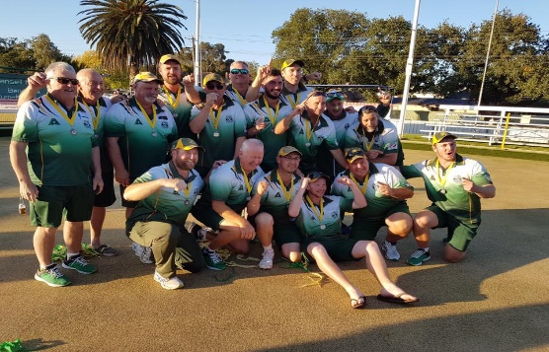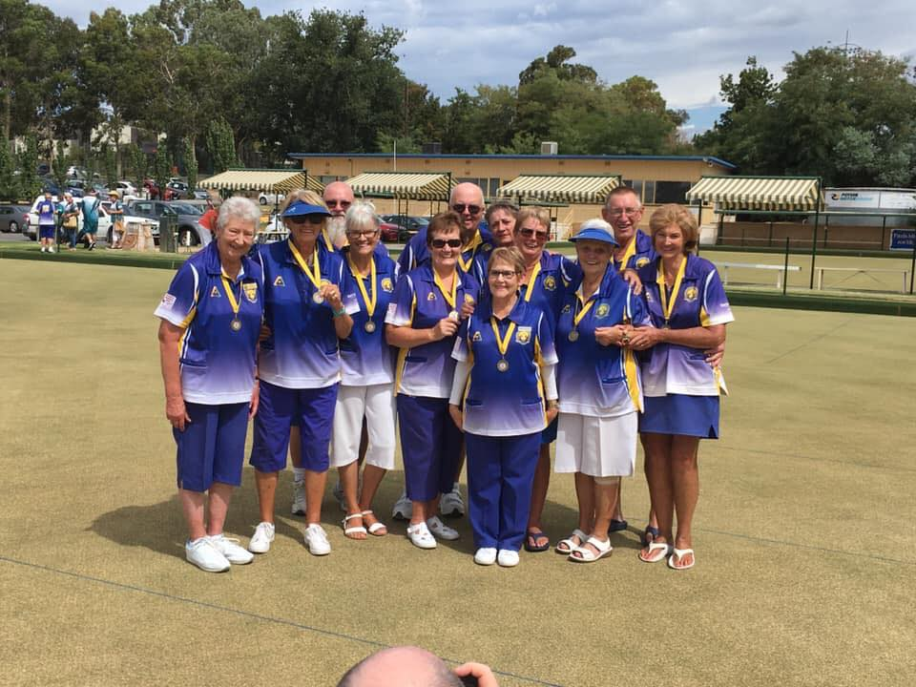
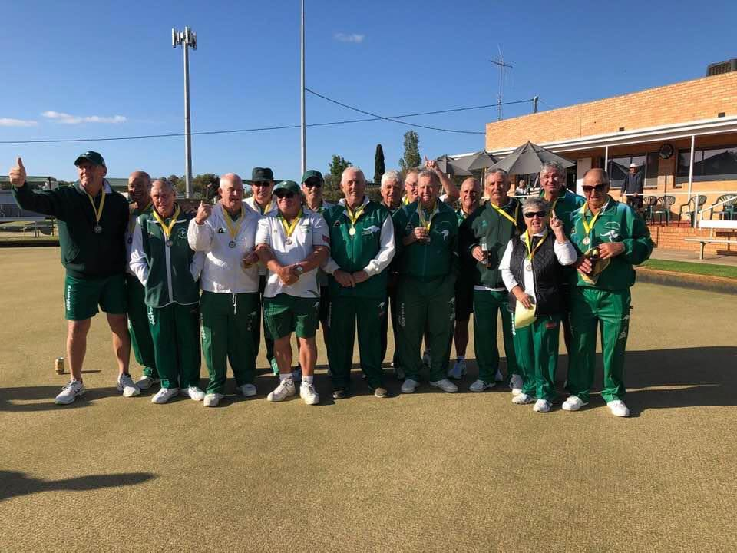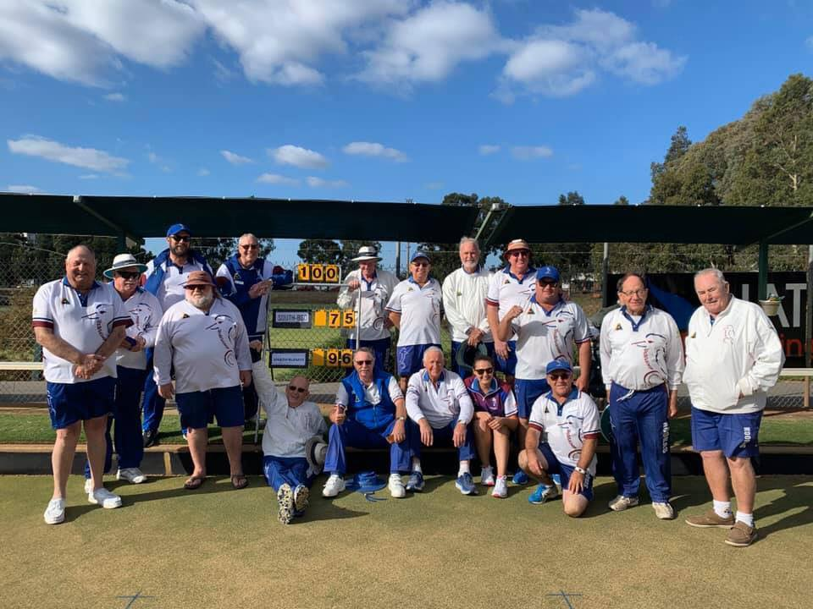

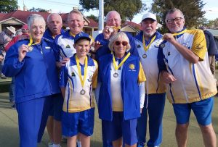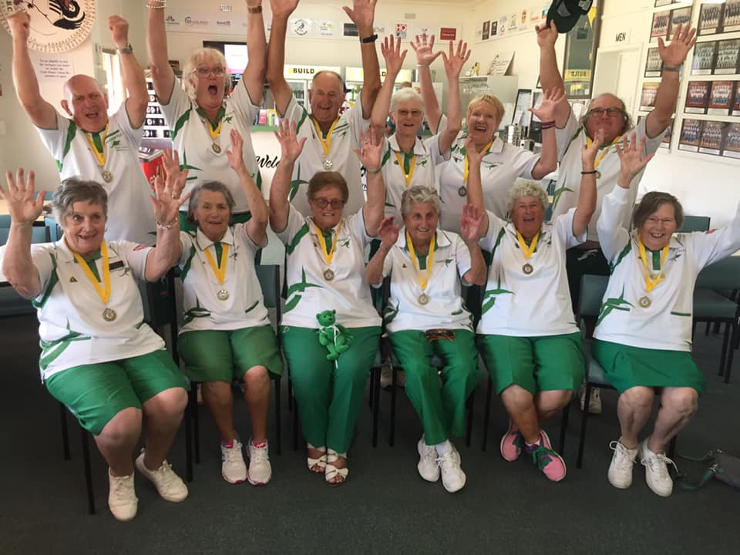
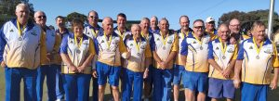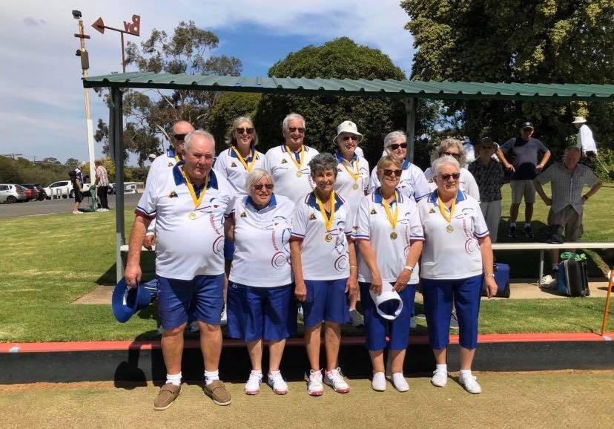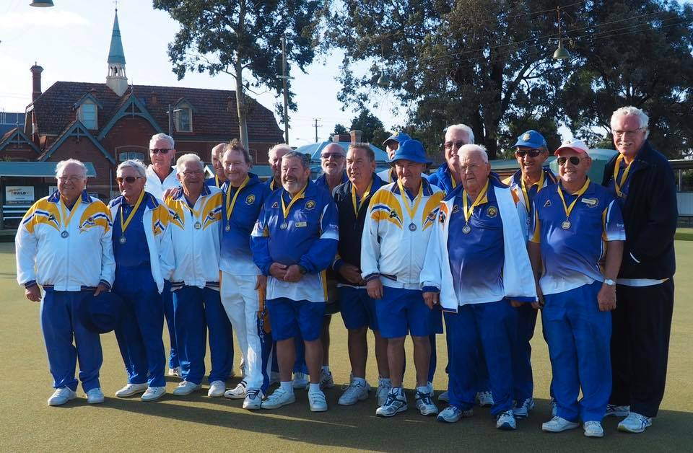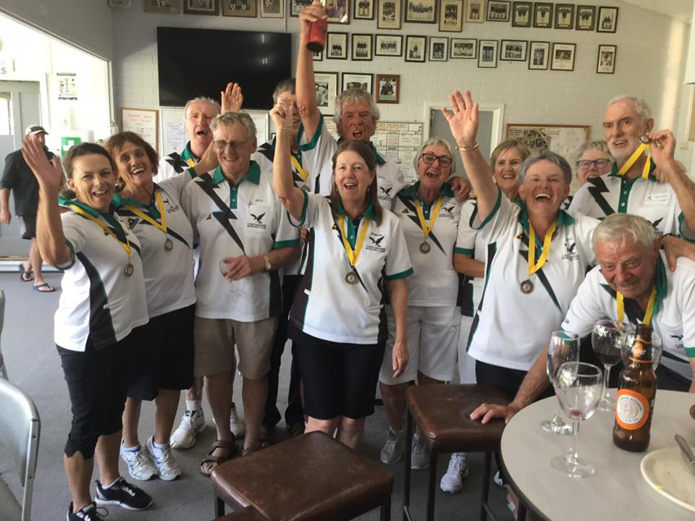

South Bendigo Weekend Div 1, Golden Square Midweek Division 1, Kangaroo Flat Weekend Div 2,
Strathfieldsaye Weekend Div 4, Harcourt Weekend Div 9, Kangaroo Flat Midweek Div 2, Harcourt Division 3, Strathfieldsaye Midweek Div 5, Golden Square Weekend Div 5, Castlemaine Midweek Div 4
-----------------------------------------------------------------------------------------------------------------------------
New Region
Seeing the Bendigo Bowls Division will be no longer after 2021 we have to have a new name for
the Region. Our Region may include those Clubs from the Goldfields Division. If you can think of a new name please advise Secretary Geoff. Ideas to date North Central Region, Northern Goldfields Region.

Michael Greenwood (Director BBD) in isolation.
THESE B… B… B… TIMES
I have always believed that the Chinese use the word “interesting” as a curse; for example, “may you live in interesting times”.
Does anybody disagree with me when I suggest the Chinese have indeed left us living in interesting times?
Lockdown, quarantine – whatever way you want to describe our current situation, the one word that succinctly describes it all is a B….. Word – BOREDOM!!!!
And it is that B… word that has led me gaily down the garden path to another B... Word.
How many of you think BOREDOM sums it all up?
No matter how much TV, or books, or phone calls, or Face Time, or Skype – or even embroidery, as one of my few friends has been doing (we won’t go into why I have few friends – there is a reason Derek Graham’s nickname for me was Grumpy).
But I digress.
I blame boredom totally for one of my attempts to pass the time.
It’s another B… word, and you will never guess what it is.
It’s BAKING. Yes, BAKING.
I have a sweet tooth and as another (another one!!!) friend knows only too well, a patisserie is my favourite haunt. Almond croissants straight from the oven anyone? My friend and I were so overcome we walked out without paying our bill.
But I digress.
While discovering the hidden depths of my pantry I found a packet cake mix. You know the type, just add water. Well actually it is more like milk, eggs, and butter.
There was a slight problem, which in my unbridled desire I decided to ignore.
The Use By date on the packet was stamped 2013, but I persevered and eventually a cake appeared from the oven.
Now, I do not know if it actually rose – for the men who are reading this, cakes are meant to rise in the cake tin.
And it didn’t fall. And it wasn’t too bad.
But this was the just the entrée.
I can use the word entrée because this is about cooking, isn’t it?
Spurred on by this success, a few days later I thought I would make some rock cakes. Men, ask your wives what these are.
I could not foresee any problems. How little did I know as I blundered on?
I had eggs, flour and sultanas.
I was not at all hindered in my desire.
Mind you, the flour was Use By 2014.
But, and there is a but, the plastic container had never been opened.
Now ladies, that fact gives you just a little hint of my baking skills.
But I digress – again.
Oh, before I forget, the sultanas were Use By 2016.
But the eggs and butter were fresh.
So, I tipped all the ingredients into a large bowl and got out my hand-held beater mix, ready to mix the ingredients.
Ladies, I hope you have all realised what I am about to do.
There is no liquid in this recipe!!
An overwhelming cloud of flour and sultanas spewed forth from the bowl!!
Stop laughing, this is serious.
All I can say in closing is that my BOREDOM was held at bay for quite some considerable time while I cleaned the benches and the cupboards, and vacuumed and mopped the floor.
…………………………………………………………………………………………………………………………………………………………….And my second B… word is BOWLS.
How I miss it. The fun, company, the game. I even miss the friendly comments on my bowling ability.
And on a serious note, I am at a loss to understand what Bowls Victoria’s Region Review could have been achieved with the impossible 2020 deadline they originally set for the review’s completion.
Why Divisions and Regions were told this was a non-negotiable decision?
When unification was first mooted seven (?) years ago each club was consulted on the matter.
And in my view, Bowls Victoria should have been announcing right from the start of the pandemic what their plans were for the recovery period.
All clubs, big and little, are going to find they are short of money, having lost revenue during the shutdown.
Perhaps some sort of financial counselling teams visiting every club?
And who wants to volunteer to find sponsorship next year. The phrase “hen’s teeth” springs to my mind.
Thank you reading this.
But above all – STAY SAFE!!!! Mike Greenwood

Veterans Day
Was held on 5th March at Golden Square, unfortunately due to weather no bowls
could be played. Some 60-70 attended.
Games were played instead and presentations of Veterans Badges were made to
our new Super Vets
Those to received badges this season were-
Men
Keith Rowley (Inglewood), Tony Aiello (Bendigo), Roy Capener (Marong), John McCurry (White Hills)
Bill Sertori (White Hills), Ken Craze (Golden Square), Carl Blaufuhs (Golden Square), Peter Edwards (Woodbury), Julian Lee (Woodbury), Des Samson (South Bendigo), Alan Cameron (Bendigo East)
Noel Kilby (Bendigo East), Michael Nihill (Bendigo East), Bill Boyle (Eaglehawk), Les Morante (Heathcote), John Hutson (Heathcote)
Ladies
Elaine Hill (Marong), Jan Scott (Marong), Jan Sertori (White Hills), Mary Harding (Campbell’s Creek)
Nola McLean (Campbell’s Creek), Wendy Lethlean (Golden Square), Joyce McKinstry (Golden Square)
Dawn Jennings (Golden Square), Irene Petering (South Bendigo), Pat Doherty (South Bendigo)
Gwen Chiron (South Bendigo), Glenda Holt (Bendigo East)

Thanks to Golden Square for hosting the event, Great Ideas for gifts and Flack Advisory for the sponsorship.
---------------------------------------------------------------------------------------------------------------------------------

Message from Deputy Chairman Arthur Harrison in isolation
Hi to all, I was to have a hip replacement but it is on hold so have spent time making toys for the grandkids in Queensland. So to everyone stay safe and see on the greens.

A 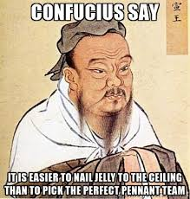

-------------------------------------------------------------------------------------------------------------------------------
A lawn bowler was involved in a terrible car crash and was rushed to hospital.
Just before he was put under, the surgeon popped in to see him and says, "I
have some good news and some bad news".
"The bad news is that I have to remove your right arm!"
"Oh God no!" cries the man "My bowling is over! Please Doc, what's the good
news?"
Doc "The good news is, I have another one to replace it with, but it's a woman's arm.
I'll need your permission before I go ahead with the transplant."
"Go for it doc" says the man. "As long as I can play bowls again."
The operation went well and a year later the man was out on the local bowls
green when he bumped into the surgeon. "G'day mate, how's the new arm?" asks
the surgeon.
"Just great," says the man. "I'm playing the best bowls of my life. My new
arm has a much finer touch and my draw bowls have really improved."
"That's great," said the surgeon.
"Not only that," continued the bowler, "My handwriting has improved, I've
learned how to sew my own clothes and I've even taken up painting landscapes
in water colours."
"Unbelievable!" said the surgeon, "I'm so glad to hear the transplant was
such a great success. Are you having any side effects?"
"Well, just one problem," said the bowler "Every time I get an erection, I
also get a headache."
---------------------------------------------------------------------------------------------------------------------------
Bowls Quiz (answers at end of Newsletter)
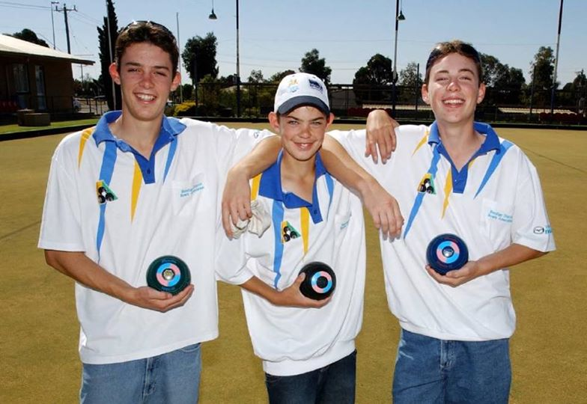
1.

Who are these Champion Bowlers (one brother missing) who started their bowls at North Bendigo

2. Which Bendigo bowler won Gold at the 1982 Commonwealth Games in the Men’s Fours? 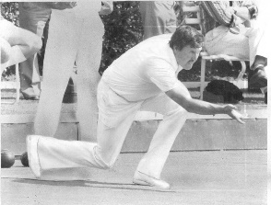

3. Two Bendigo Division Ladies have won the Victorian State Champion of Champions (one twice).
Name them?

4. Who are the 4 Regions/Divisions who play for the Provincial Championships each year?

5. Bendigo Bowls Club was formally known as what?

6. What years the following Clubs were formed Castlemaine, South Bendigo, Dingee and Kangaroo Flat?

7. 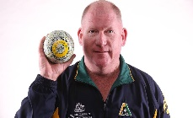Did this Bowler ever play in a Division 1 Pennant match for South Bendigo?

8. 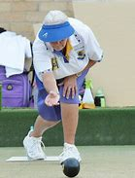 Who is this bowler?

9.
Who is this member of the BBD Board?
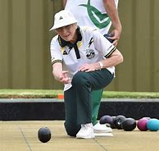

10. In What year did Ian Ross win the Australian Singles?

11. Name the missing players from these State Championships winning teams?
2004/05 Women’s State pairs Bronwyn McDermott and ???
1998/99 State Mixed Pairs Pam Wheelhouse and ???
2006/07 State Fours- Pam Hunter, Val Passalaqua, ??? and J Lourie
2016/17 State Fours- Darren Burgess, Gary Ryan, Chris Randell and ????
2014/15 State Fours- David Morris, Gary Ryan, ???? and David Keenan

12. Which 2 Clubs won 3 Pennants this season in Midweek and Weekend Pennant?
---------------------------------------------------------------------------------------------------------------------------------

Message for BBD Director Tony Doolan
Hi All
I hope you are all well in this uncertain time l am missing my Bowls as I am sure you are to.
I would like to make some comments regarding the proposed restructure 0f our Bowls Administration by Bowls Victoria
I have concerns these changes will impact badly on our district bowls, which I regard as very good at this present time. We have 22 clubs (8 being country clubs) surrounding Bendigo. Bendigo would be these clubs business centre. The relegation and promotion system works very well in our district. Encouraging teams to find their best playing position. Travel distance is very reasonable between any two clubs.
The proposals being put forward by Bowls Vic would mean a much bigger District/Region, ranging just north of Ballarat to Deniliquin, which would mean a two hour drive. This would be difficult for club delegates as well the single administration of such a huge area (40 plus clubs) would be huge for volunteers.
Eg 4 rink teams as well as 3 rink teams with different playing conditions.
The existing districts would lose their independence. I feel changes to our District/ Region should not be made without full consultation with all our District Clubs.
If it cannot be shown to be of any benefit to our district we should not be supporting these directives from Bowls Vic.
I will finish with this adage “If it is not broken don’t fix it”.

Tony Doolan

GEOFFs Magic Slice
Ingredients
1½ cups (180 grams) plain biscuit crumbs
75 grams unsalted butter, melted
1 cup chocolate bits, melts, chips
1 cup sultanas
1 cup desiccated coconut
1 cup sliced almonds (or chopped walnuts)
1 x 375g tin of condensed milk
Instructions
Preheat oven to 180°C.
Blend or crush biscuits to a fine crumb. In a medium sized bowl, mix the crumbs with melted butter and combine well before pressing into a lamington tin and press down firmly, but gently, using the back of a metal spoon.
Mix all remaining ingredients together in a large bowl. Gently pour over the base and bake at 180 degrees for 25 minutes or until golden.
Wait until cold to cut.
Keep it in the fridge
You can substitute any of the topping ingredients for this amazing slice - I have made with a variety of combination of nuts and dried fruit, all have resulted in deliciousness!
---------------------------------------------------------------------------------------------------------------
History of Bowls in Bendigo
The earliest records available for the Association are from 1890 when the Association was known as the North West Bowling Association.
It apparently carried on under this name until 1925/26 when a change was made to the Northern Bowling Association.
In 1933-34 it became the Bendigo District Bowling Association.
The earliest Clubs mentioned are Bendigo, which played as Sandhurst Bowling Club in 1870/71, changing its name to Bendigo in 1872. Eaglehawk was founded in 1885 and Castlemaine in 1886.
Heathcote was formed in 1904 and South Bendigo in 1905. Maldon, Kyneton and Daylesford Clubs received early mention.
The earliest bowls results go back to 1891, Bendigo Club winning the “A” Pennant in 1891 and 1894, with Castlemaine in 1892 and 1893.
Eaglehawk won in 1895, 96 and 97 to win outright the North West Association Cup, which they still proudly hold. A further win in 1898 made four in a row, a record which was not equalled until 1959/60 to 1962/63 when Golden Square won four and in 1973/74 to 1976/7 when Bendigo also were successful.
The first recorded singles Championship winners were T.F. Reid, Castlemaine 1894 and J Murley, Eaglehawk in 1895.
The ‘A” and “B” pennant competitions continued and in 1907 the Champion of Champions series commenced – winner J Murley-Eaglehawk.
In 1908 the Bendigo Club opened its new Pavilion on 21st October. In 1909 it is noted F Dobbie of the Bendigo Club won both the Singles Championship and the Champion of Champion title. In 1913 J Smalley of Eaglehawk won the Country Bowls Singles Championship.
In 1915 reference is made to the Pairs Championship for the first time, being won by Van Heuren and Baker, Castlemaine.
In 1917/18 A E Brown (captain) H Taylor, J Keck and J Laidler of South Bendigo won the VBA Country Fours.
In 1920/21 Pennant was conducted in two sections, Northern and Southern. The play-off between Eaglehawk (Northern) and Castlemaine (Southern) was won by Castlemaine.
With the introduction of the Northern Bowling Association in 1925/26 “A” Pennant teams became four rinks.
In 1950/51 there were 11 clubs now we have 22. These are date with entry date- Bendigo (1890) Bendigo East (1948) Bendigo Golf (1914) Bendigo VRI (1965) Bridgewater (1934) Calivil (1963) Campbell’s Creek (1965) Castlemaine (1890) Dingee (1964) Eaglehawk (1890) Golden Square (1922) Harcourt (1955) Heathcote (1904) Inglewood (1930) Kangaroo Flat (1945) Lockwood South (?) Marong (1926) North Bendigo (1966) Serpentine (1965) South Bendigo (1905) Strathfieldsaye (1985), White Hills (1951) Woodbury (1976)
In 2015 Bendigo Golf ceased due to lack of numbers and committee.
What does 2021 hold??????
----------------------------------------------------------------------------------------------------------------------------------

A man was walking down the street when he was approached by a particularly
dirty and shabby-looking homeless man who asked him for a couple of dollars
for dinner. The man opened his wallet, took out ten dollars and said, "If I give you
this money, will you buy some beer with it instead of dinner?"
"No, I had to stop drinking years ago," the homeless man replied.
"Will you spend this on nomination fees at a bowling club instead of food?" the
man asked.
“Are you NUTS!" replied the homeless man. "I haven't played lawn bowls in 10
Years!" "Well," said the man, "I'm not going to give you money. Instead, I'm going
to take you home for a hot shower and a terrific dinner cooked by my wife."
The homeless man was astounded. "Won't your wife be furious with you
for doing that? The man replied, "That's okay. It's important for her to see what a guy
looks like after he’s given up drinking and bowls.”
---------------------------------------------------------------------------------------------------------
Annual General Meetings -----Consumer Affairs Victoria is providing advice for incorporated associations to help them manage their obligations during the coronavirus (COVID-19) crisis. This advice covers:
Holding regular meetings, including their Annual General Meeting (AGM); Special General Meetings (SGMs) or other meetings; and lodging annual statements with Consumer Affairs Victoria
having their financial statements reviewed or audited (if applicable).

AGMs, SGMs and lodging your annual statement
From midnight 25 March, incorporated associations conducting meetings must observe social distancing measures, to combat the spread of coronavirus (COVID-19). If your incorporated association is scheduled to hold a meeting you should consider:
Using alternative means to hold meetings, including teleconference or video conference – we recommend this for all incorporated associations, particularly for larger ones.
Please note: the Associations Incorporation Act 2012 (the Act) permits members to take part in general meetings by using technology that allows members to clearly and simultaneously communicate with each other, regardless of the incorporated association’s rules regarding this
Proxy voting – If using this method, you must use a standard form, subject to the rules of the incorporated Association. Members must be given a copy of that form with the notice of the AGM/Special General Meetings. A person acting as a proxy must act honestly and in good faith and exercise due care and diligence
Applying for an extension of time to hold your AGM. The Registrar will provide all associations an extension of three months and waive the fee.
To seek an extension please complete our extension of time to hold an AGM or lodge financial statements form and submit to cav.registration@justice.vic.gov.au.

Umpire, Measurer & Marker Accreditation & Re-Accreditations
Due to current circumstances surrounding COVID-19, officials that were required for re-accreditation (including Markers, Measures, Umpires) will now have their accreditation extended for a further 12 months.

Quiz Answers

1. Cameron, Aaron and Matthew Wilson. 2. Don Sherman (South Bendigo)
3. H Hill (South Bendigo) twice and M Kelly (Eaglehawk) 4. Bendigo, Ballarat. Geelong and Wimmera.
5. Sandhurst Bowling Club. 6. Castlemaine 1886, South Bendigo 1905, Dingee 1964, Kangaroo Flat 1945.
7. Yes for a night pennant game (Steve Glasson) 8.Patti Pain (Golden Square), 9. Ann Howe (South Bendigo), 10. 1988 11. Glenda Holt, Ken Rusbridge, Patti Devereaux, Aaron Tomkins, Brad Holland.
12. Kangaroo Flat and Woodbury.

